51. Implement a C Program to Reverse – SLL.

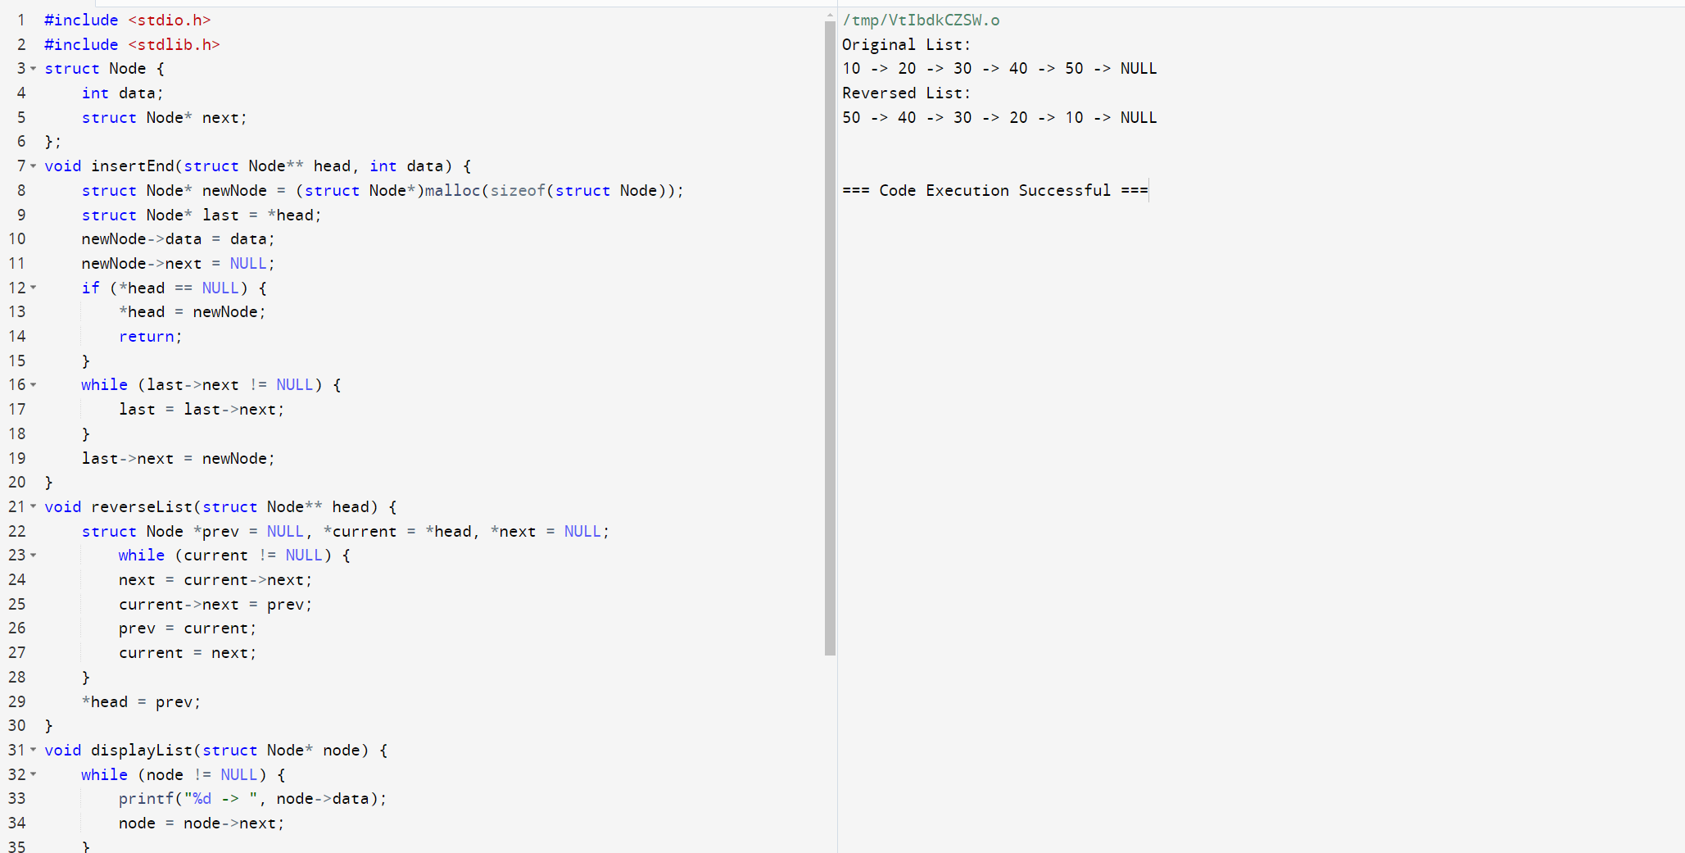

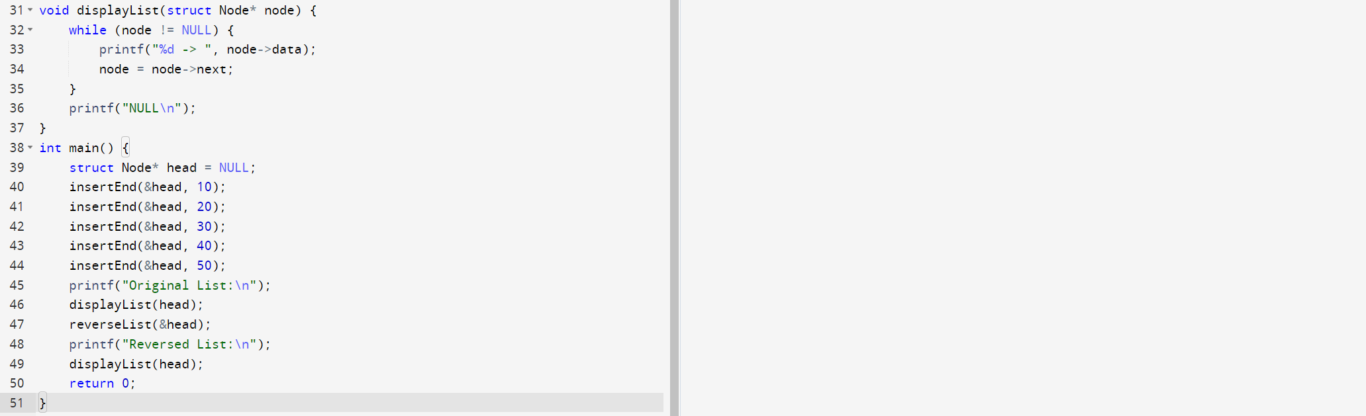

52. C program to print Factorial of a number applying Recursion.

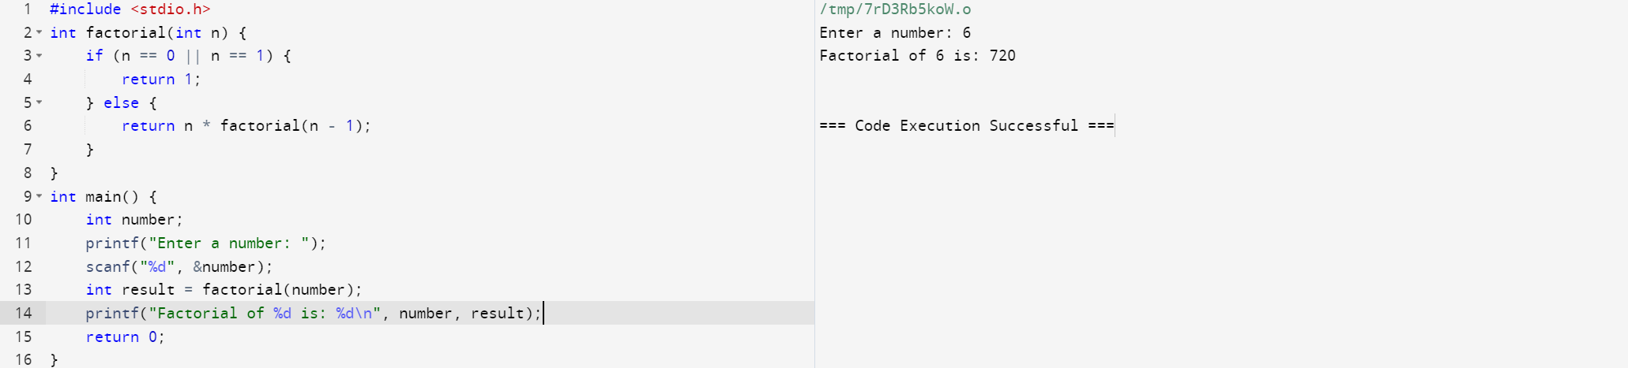

53. Implement a C Program to Merge two Arrays.

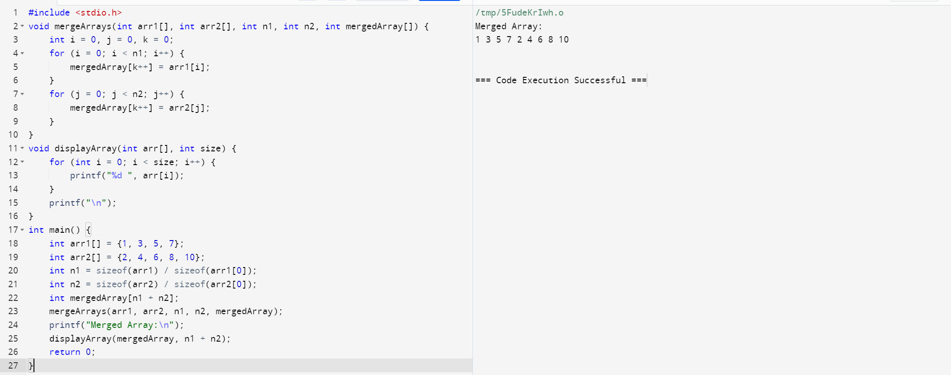

54. C program to print Fibonacci of a number without using Recursion.

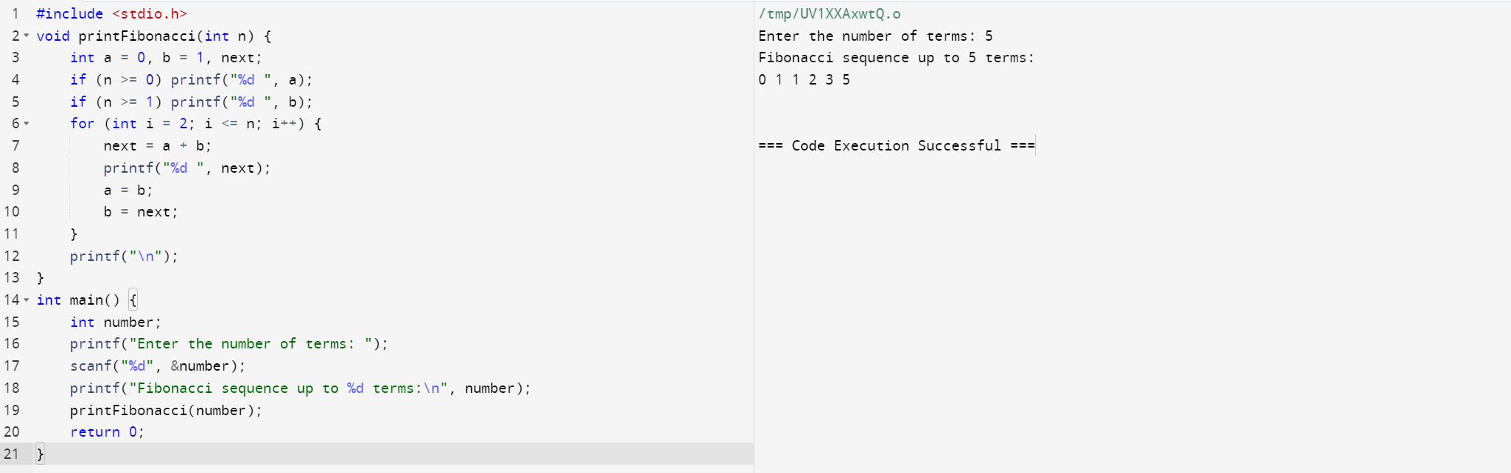

55. C program to print Factorial of a number without using Recursion

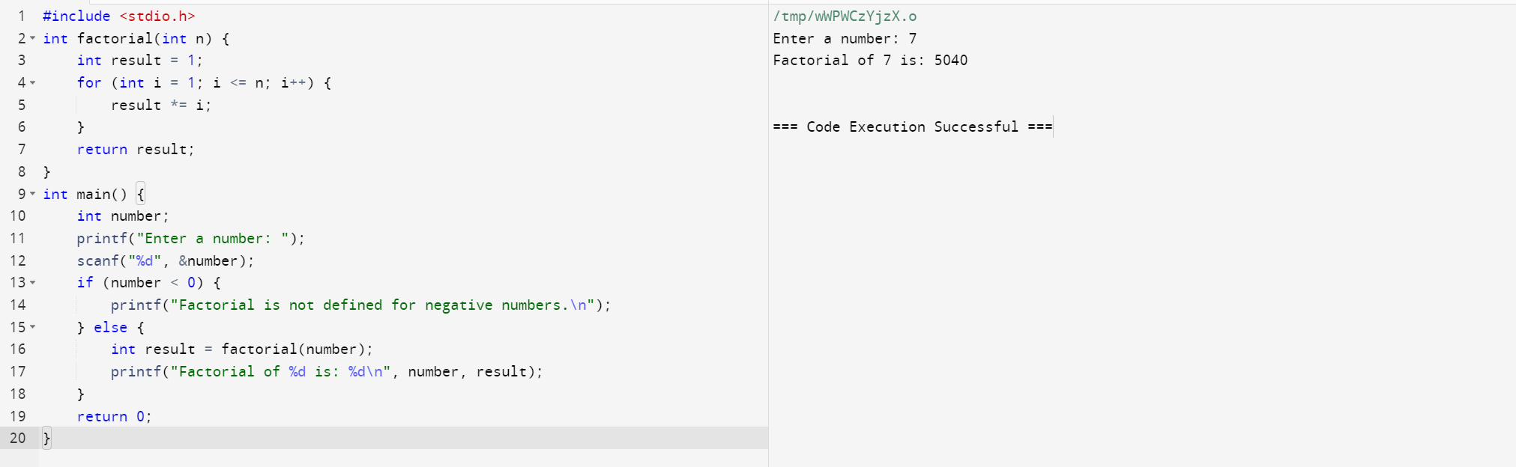

56. Implement a C Program to perform Tree traverse – Post order.

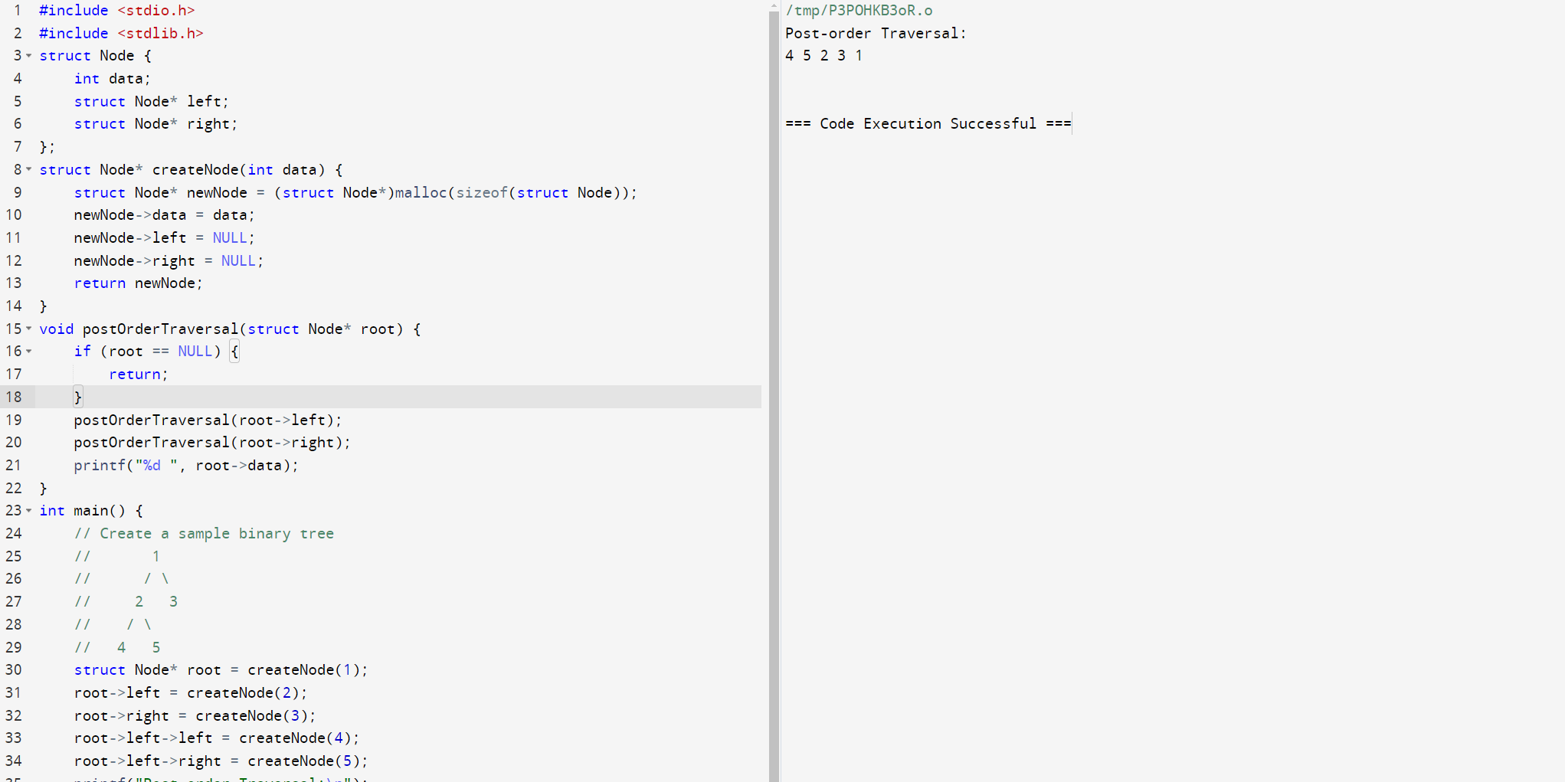

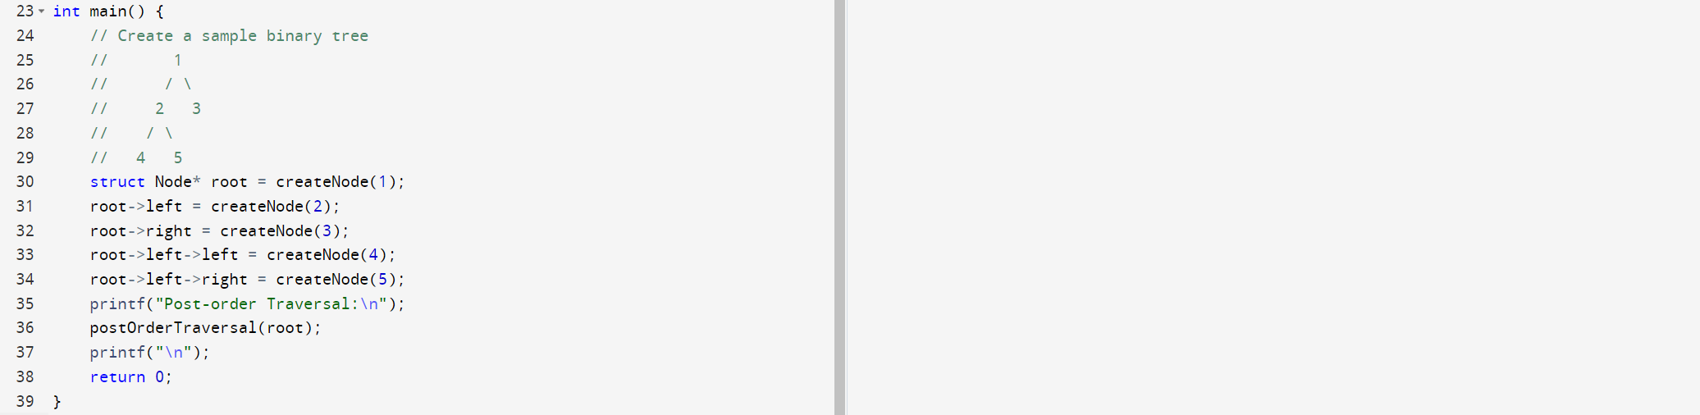

57. . Write a C program to implement a stack and accept some numeric values. Find the top and kth element of the stack. >

Expected Output: Elements of the stack: 1 2 3 4 5 6

Top element: 6

3rd element from top: 4

Remove the topmost element from the stack: Elements of the stack: 1 2 3 4 5

Top element: 5

4th element from top: 2.

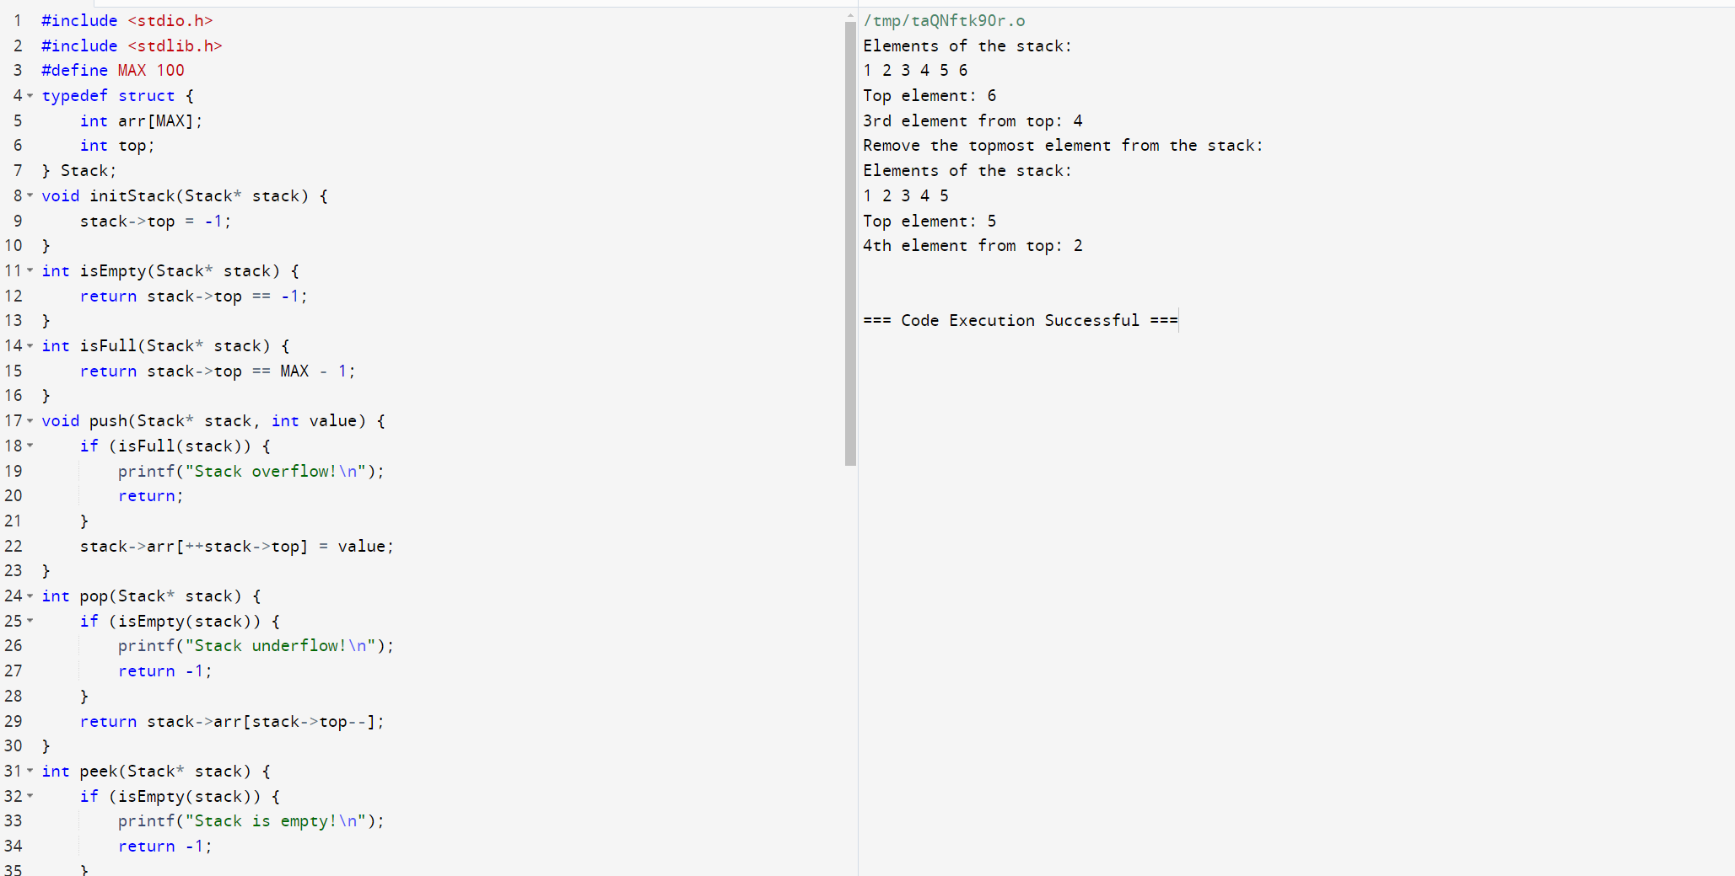

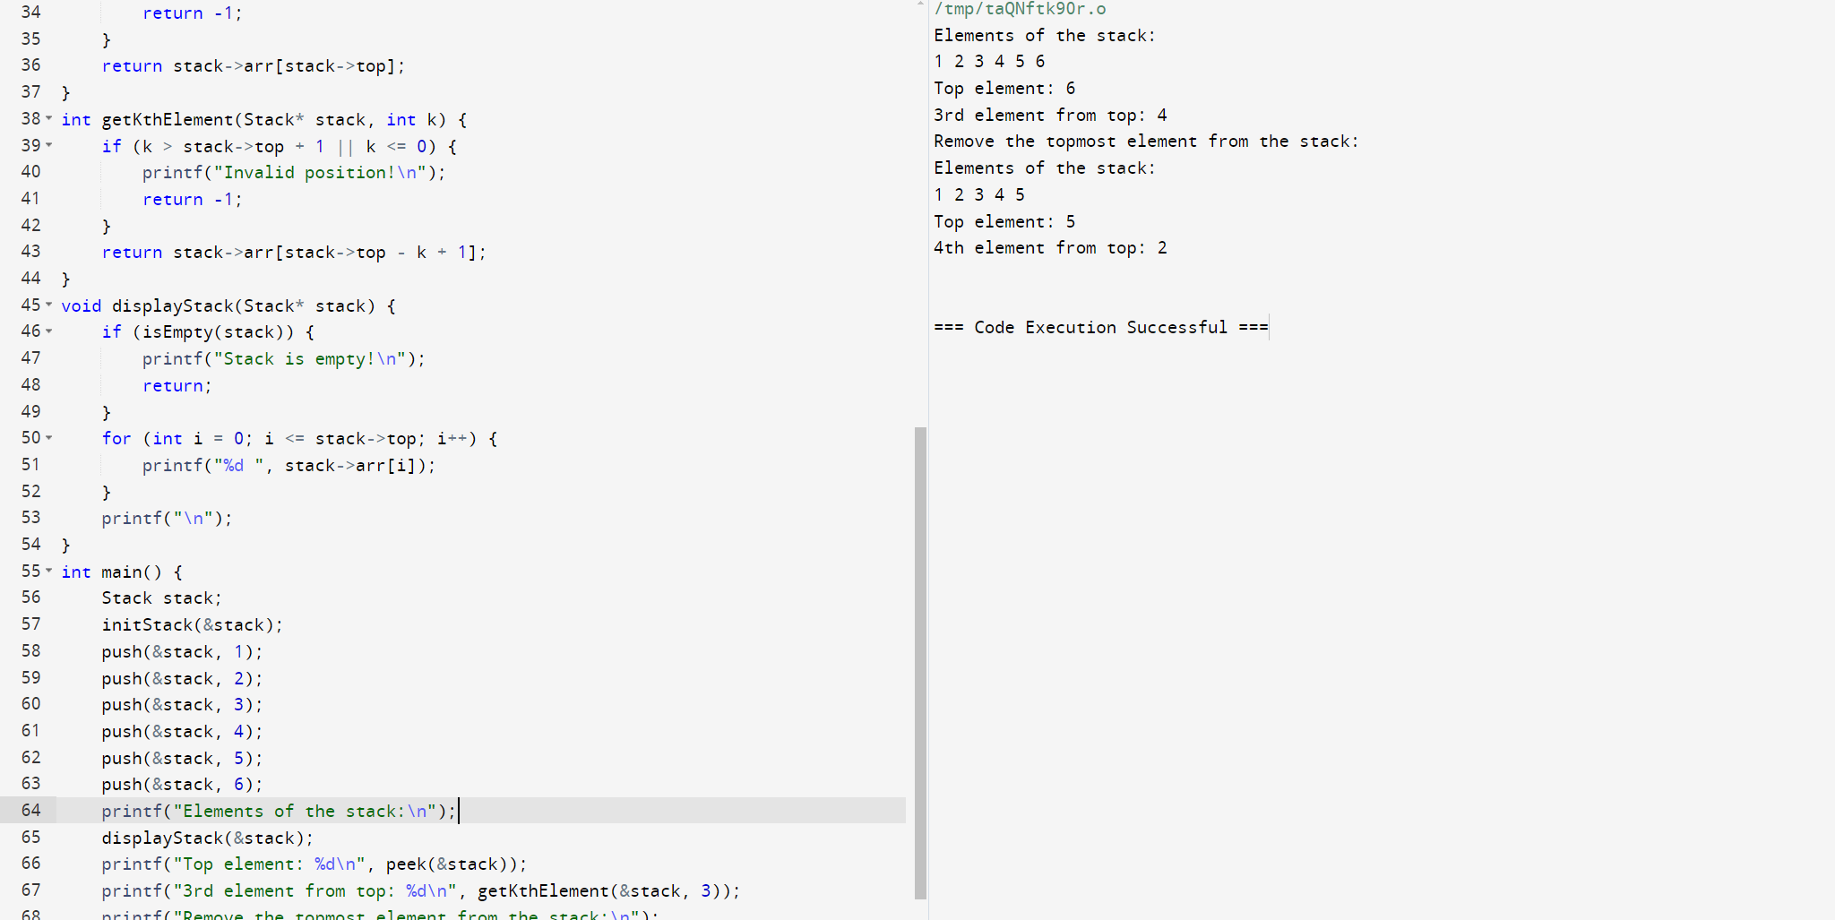

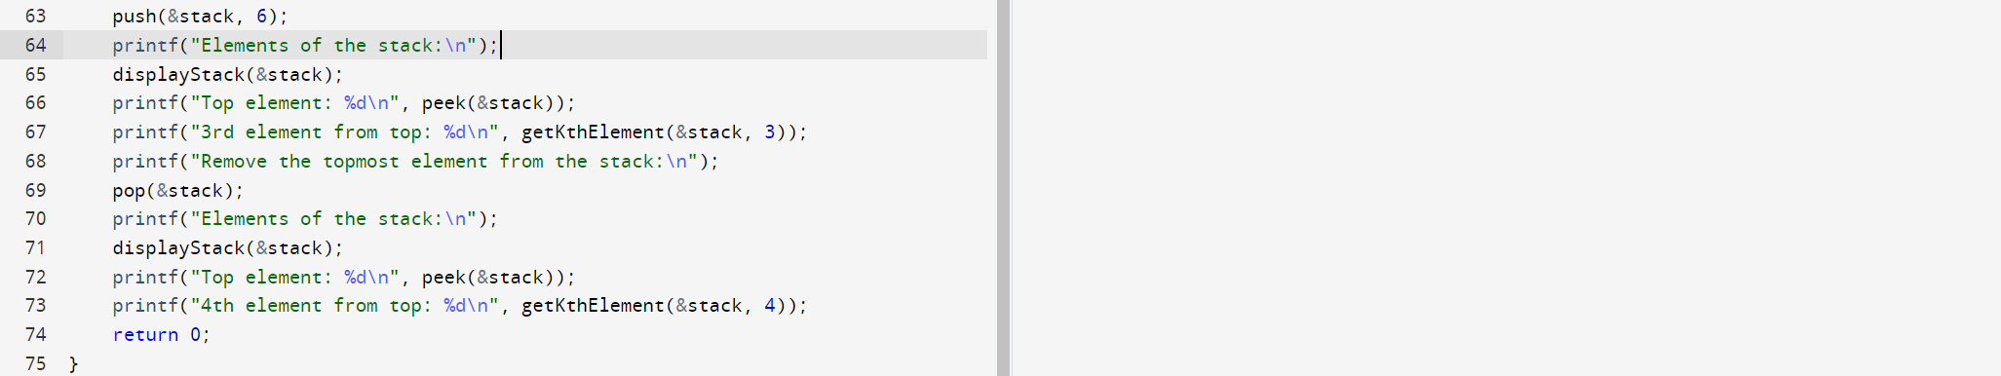

58. . Write a program in C to print the Fibonacci Series using recursion. >

Test Data : Input number of terms for the Series (< 20) : 10

Expected Output: Input number of terms for the Series (< 20) : 10

The Series are : 1 1 2 3 5 8 13 21 34 55

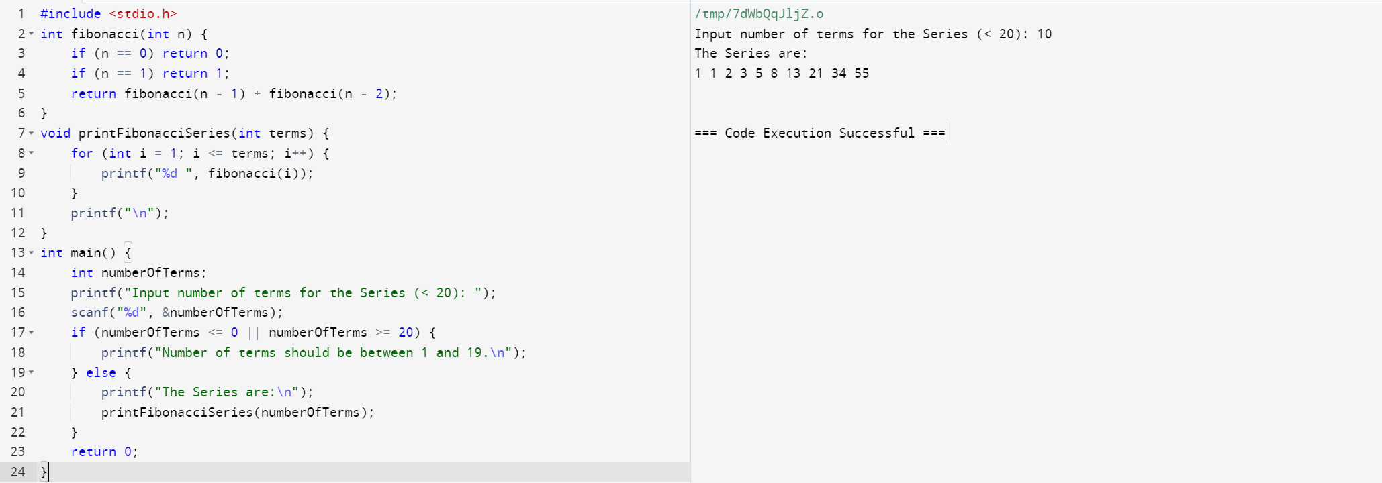

59. Write a C program to reverse the digits of a 32-bit signed integer. > Expected Output: Original integer: 1 2 3

Reverse integer : 321

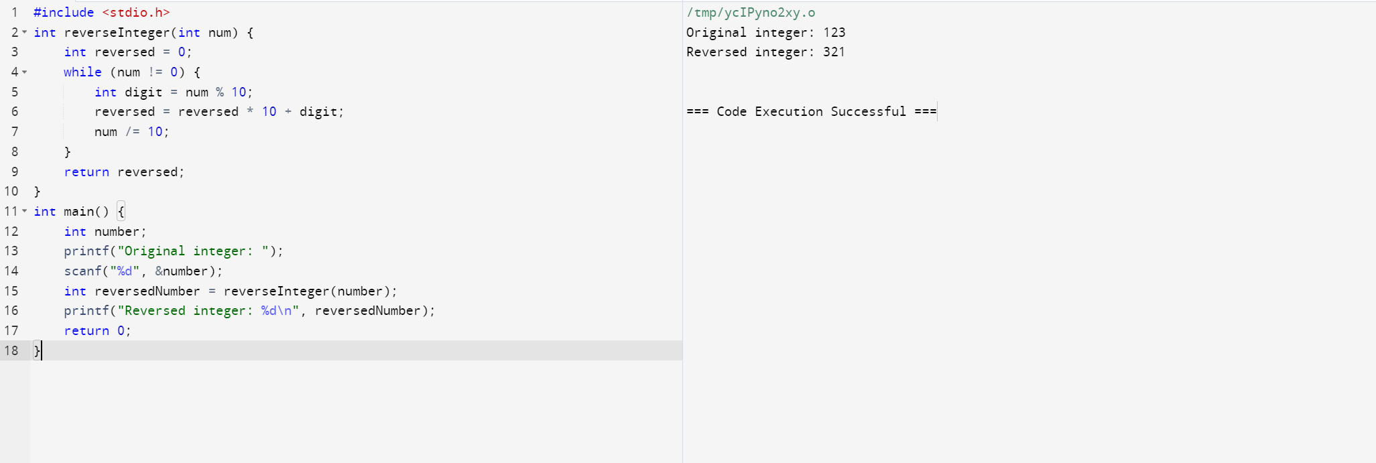

60. Write a program in C to create a singly linked list of n nodes and display it in reverse order.

Test Data :

Input the number of nodes : 3

Input data for node 1 : 5

Input data for node 2 : 6

Input data for node 3 : 7

Expected Output :

Data entered in the list are :

Data = 5

Data = 6

Data = 7

The list in reverse are :

Data = 7

Data = 6

Data = 5

